申請停車證的標準作業流程
4. Parking Permit SOP
The Standard Operating Procedure to Apply for Parking Permit

步驟一 STEP 1 (at least 4 days before proposal or defense meeting)
請教校外委員是否開車來，若需辦理停車證請先到所網下載範例進行修改。經所辦及所長核章後，可於口試前1~3天跑停車證流程。
Ask how your committee will come to NTNU (By car? High speed rail?)
Parking permit: If your committee will drive to NTNU, please download the sample file from IHRD website (download > Defense), modify the text, and send to the IHRD office staff at least 4 days before defense date. Come to get the parking permit form stamped by the IHRD office and director to apply for parking permit.

步驟二 STEP 2 (1~3 days before proposal or defense meeting)
從所辦到停車場的路線圖，停車場入口在學校的操場旁邊
Please follow the route to get to the entrance of the parking lot (from IHRD office), the entrance of the parking lot is next to the school track
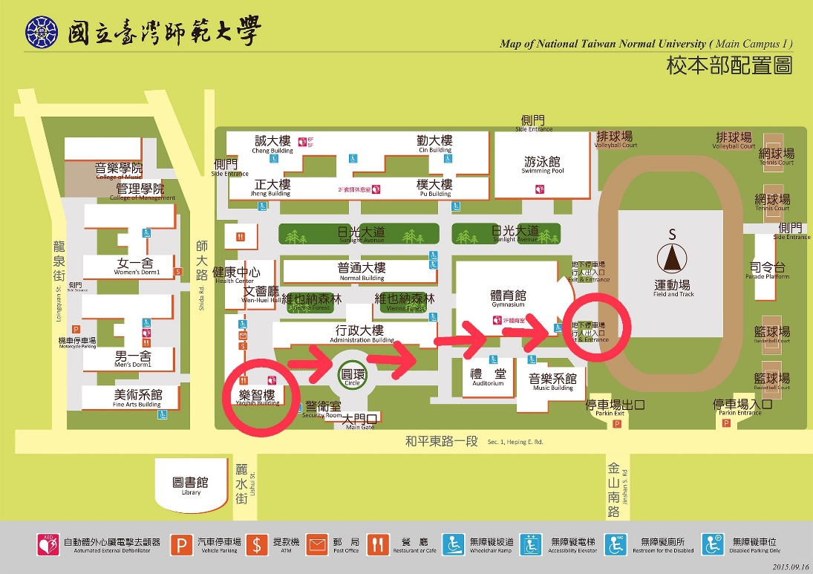

步驟三 STEP 3
下樓後，向右轉後直走，辦公室就在右手邊（辦公室門口如圖所示）
After going downstairs, turn right and keep going straight, the office is on your right-hand side. (the office entrance is as shown)
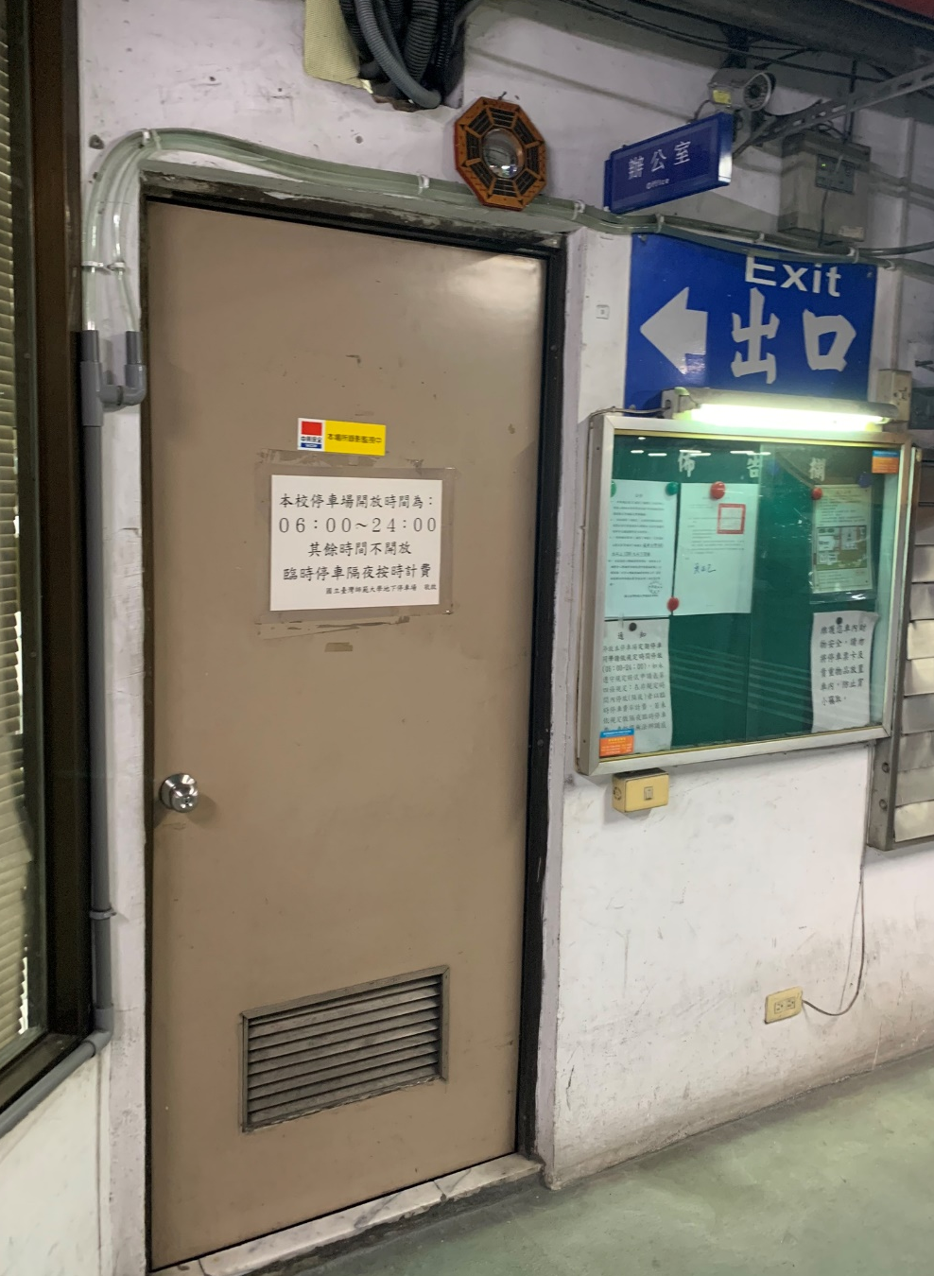

步驟四 STEP 4
辦公室工作人員會在申請書上蓋章 （圖上圈起來的地方）
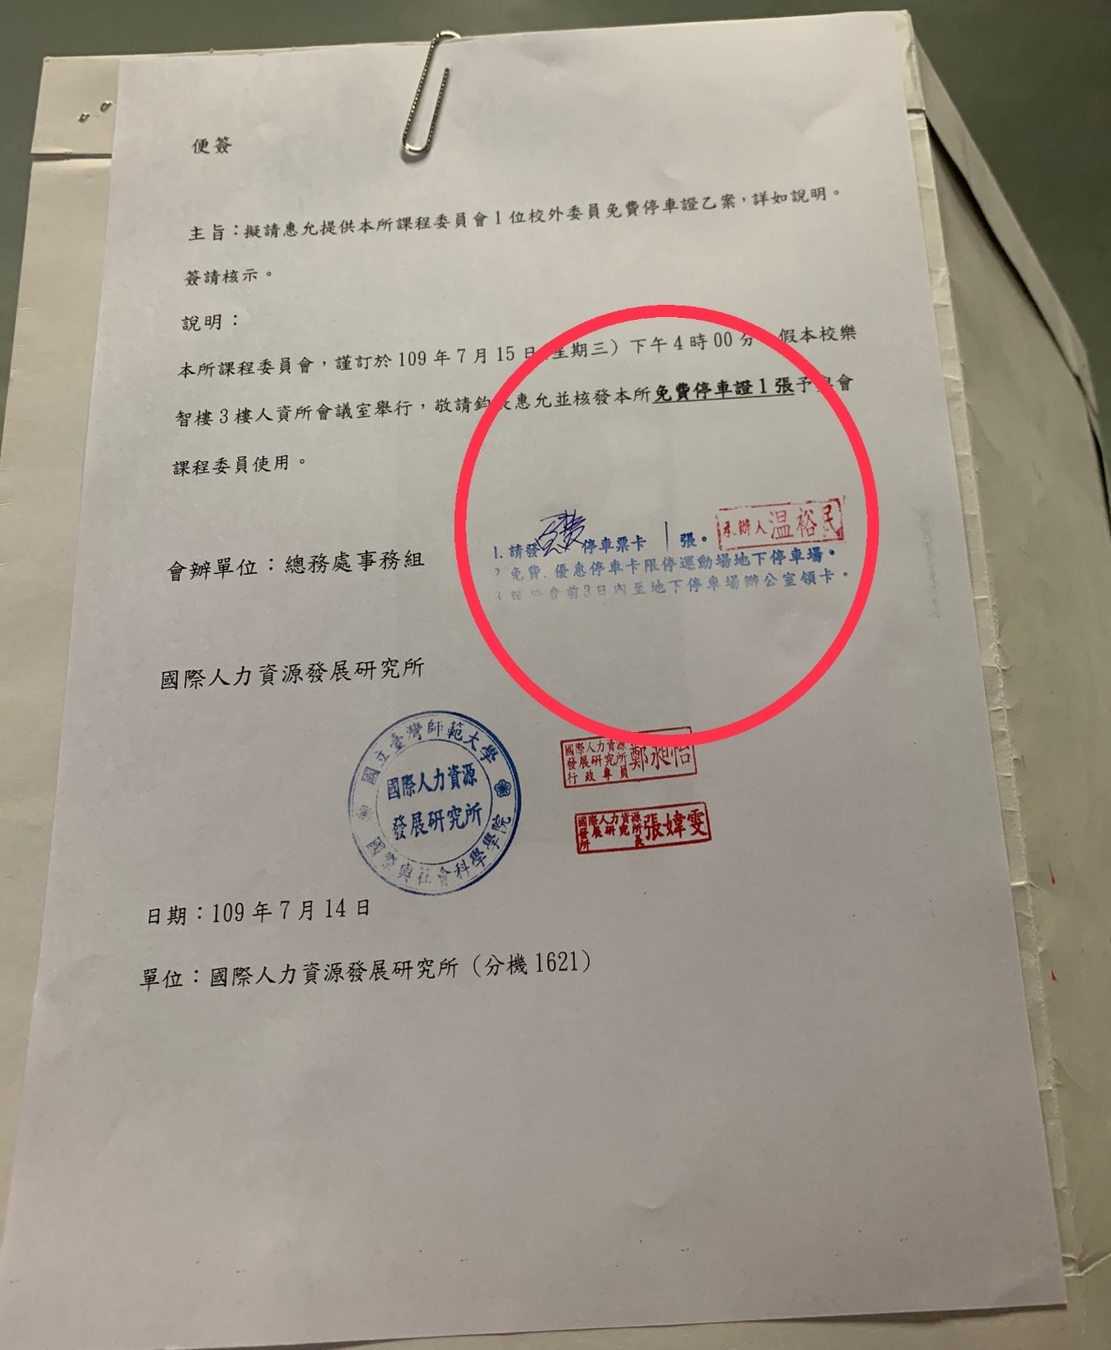
Tell the administration staff that you want to apply for parking permit, they will stamp on your paper (the circled place on the picture)

步驟五 STEP 5
完成蓋章後，將申請書交給隔壁的管理員室的工作人員，即可拿到停車證
（管理室門口如圖所示）
After stamping, go to administrator room next door, hand the paper to the administration staff inside, and you can get the parking permit
(the entrance of the administrator room is as shown)
